# **CS370: Assignment-1 - Documentation**

**Family Name:** Goh

**First Name :** Wei Zhe

**Email id : weizhe.goh@digipen.edu**

_________________________________________________________________________

Declaration:

I hereby declare that I adhere to the Academic Integrity Policy stated in the syllabus document. In addition, I also declare that the output images shown in this document are solely taken from the project that I have implemented for this assignment and the same output image will be generated when run in any Digipen PCs using the submitted project.



_________________________________________________________________________

# **Part-A (1)**: Mean Filter and Local Noise Reduction (LNR) Filter

**Noisy image Mean Filter output LNR Filter output**

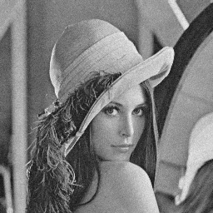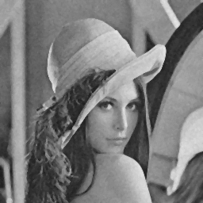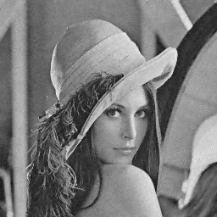

Gaussian noise generated with mean 0, variance 50

Gaussian noise generated with mean 0, variance 150

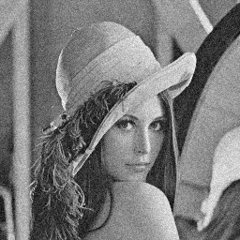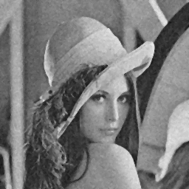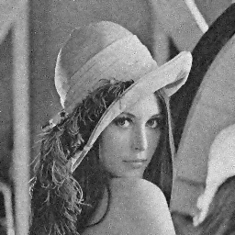

**Discussions:**

In general, the adaptive filter performs better. It produces an output with reduced noise, yet still maintaining the sharpness of the image. The mean filter reduces noise as well, but the overall output is much blurrier than the output of the adaptive filter.

# **Part-A (2):** Median Filter vs Adaptive Median Noise Reduction (AMNR) Filter

Noisy image Median Filter output AMNR Filter output

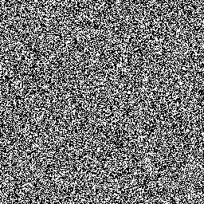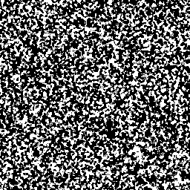

Salt-and-pepper noise generated with P(a) = 0.5, P(b) = 0.5

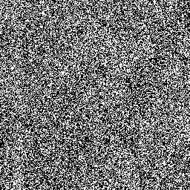 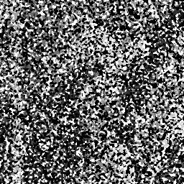 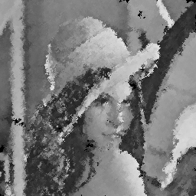Salt-and-pepper noise generated with P(a) = 0.4, P(b) = 0.6

**Discussions:**

In general, the adaptive filter performs much better here too. It is very clear in the second example. The adaptive filter manages to extract out the Lena image from the very noisy input. The median filter fails to extract any useful information out from the noisy input. However, on a usual use case like in the third example, the median filter performs nearly as well as the adaptive filter. For the first example, there is no way for any filters to extract any meaningful information. This is due to the fact that P(a) and P(b) are both 0.5, resulting in a output image consist purely of noise, without any information from the original image.

Additional Information to the Instructor:

1. Any addition information that is general to this assignment
2. Any extra steps that you have taken for this assignment
3. …

**\*\*\*Include other relevant sections as you need to provide information about your implementation**